Deployments

Imagine that you have deployed application inside kubernetes cluster about a year ago, now you have upgraded the app from v1 to v2

**Can you upgrade the app with zero downtime?**

**Can we upgrade the sequentially, one after the other?**

**Can you pause and resume upgrade process?**

If anything happen to upgrade. **Will you able to rollback to the previous stable release?**

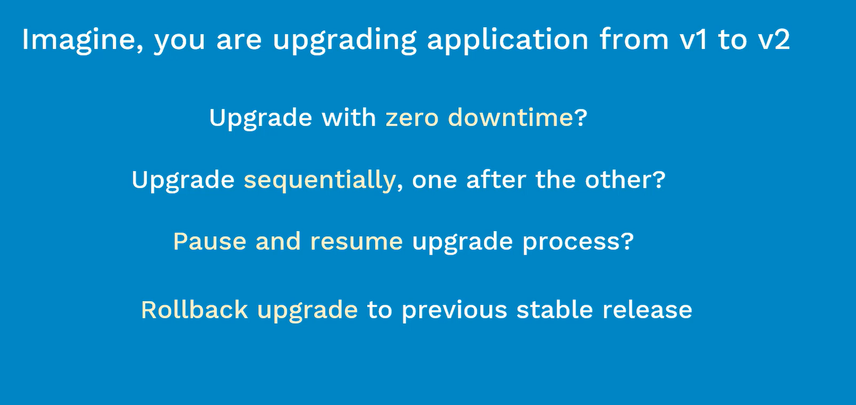

The above some important questions that you need to think before upgrade any app from current version to newer version especially doing in the production environment.



1. What is deployment?
2. What are its features?
3. What are different types of deployments?
4. How to deploy and manage app instances inside kubernetes cluster using deployment?

Before get to know about deployments, we need to have an idea of ReplicaSet, Pods and kubernetes

**Objectives:**

## Concept:

* Deployment Overview

What is deployment? How it is related to ReplicaSet and Pods?

* Features
* Types of Deployment

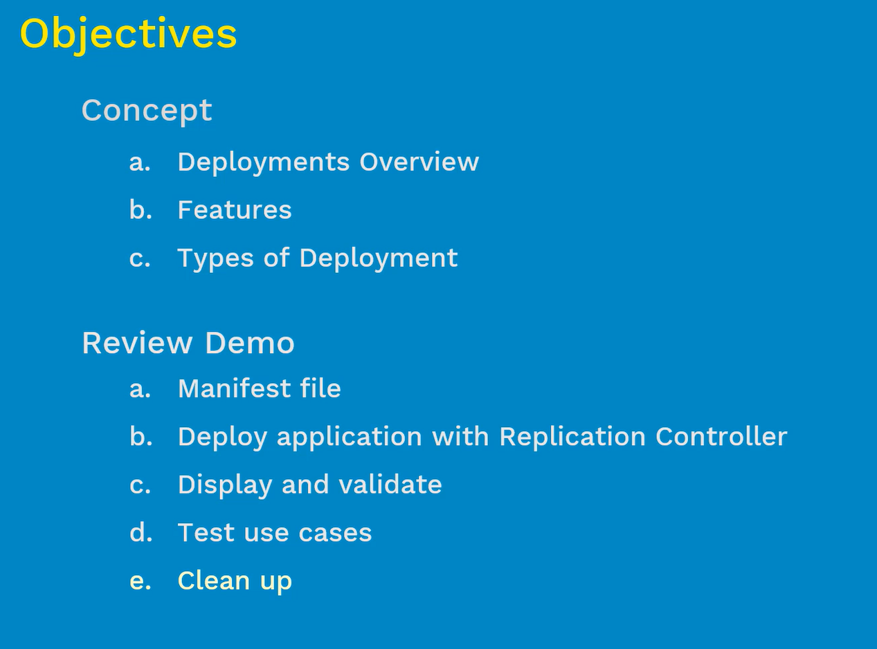

# Deployments:

* Deployment is a controller just like Replication Controller and ReplicaSet
* Special about deployment – on high level deployment is all about **Updates & Rollbacks**
* A Deployment Controller provides declarative updates for pods and ReplicaSets
* These updates are not only just changing the older version number inside the spec file to a newer version, it also includes increasing or decreasing number of pod replicas

#### Explanation:

Generally we deploy Microservices application through the container. In Kubernetes, related containers are grouped together inside a pod.

Technically like this.

To have High availability and Load Balancing, we prefer to have more than one pod running on the cluster.

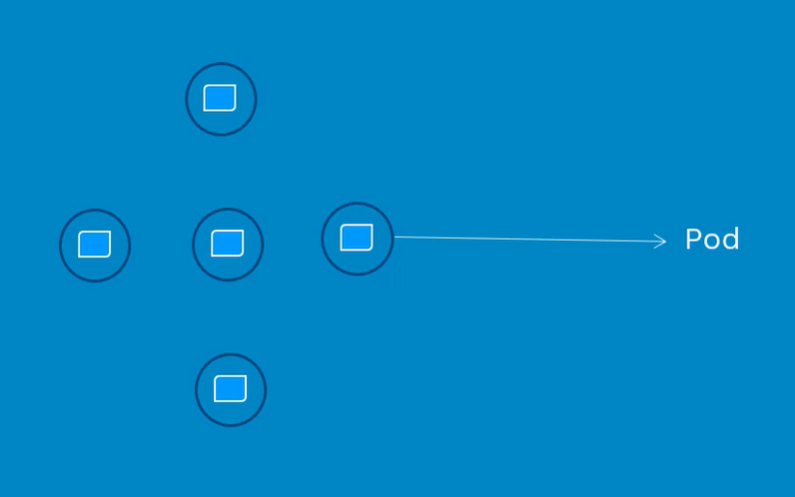

**Five pods for HA and LB, we will do this by ReplicaSet**

But ReplicaSet doesn’t provide features such as Upgrades & Rollbacks

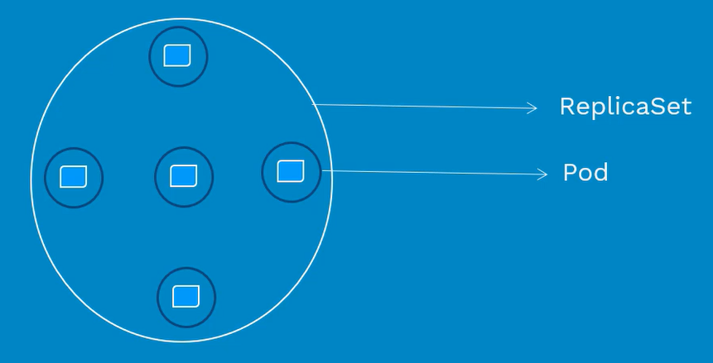

For Upgrades & Rollbacks, we need deployments

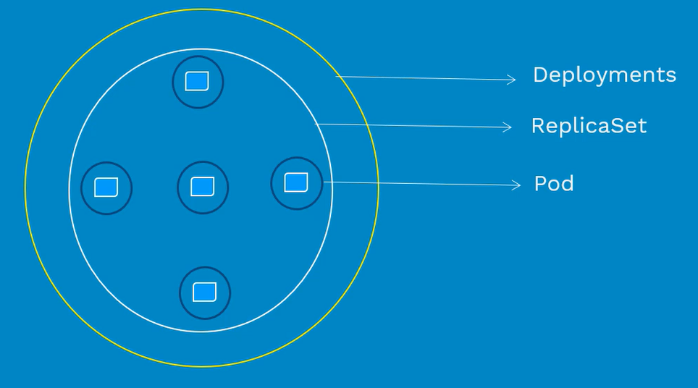

Overall, we are looking at three different objects, PODS, ReplicaSet, Deployments.

So the question is, **do we require three different manifest files for each one of these?** Answer is **No**

We can manage all three configurations in one single deployment file. Deployment manifest file contains of pod definition, number of pod replicas and mention about preferred upgrade strategy. We manage all using in Deployment manifest file.

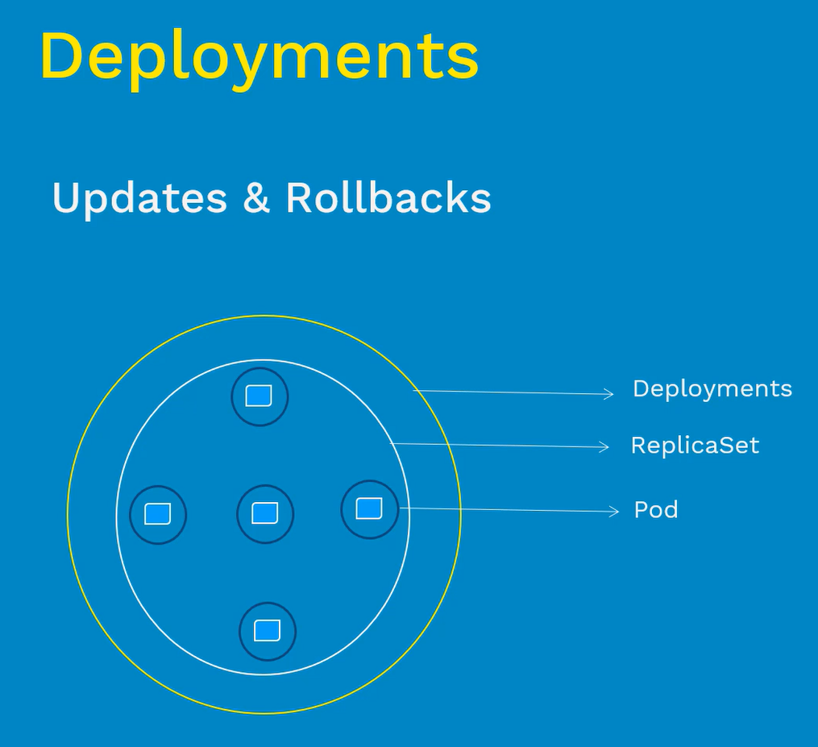

## Features:

* **Multiple Replicas** – with the help of deployment we can deploy multiple replicas of pods for HA and LB. When we create deployment by default kubernetes will automatically create replicaset for you. In case, if we don’t mention replicas in manifest file Deployment will create with a replicaset as 1. Advantage of using having replicaset as 1 is make sure one pod is running always. By some reason the pod dies, it will create automatically one pod on same node or healthy node
* **Upgrade** – upgrade is one of the core feature of the deployment. There are different types of upgrades
* **Rollbacks** – If something wrong with current upgrade then deployment controller will rollback to previous stable version
* **Scale up or down** – based on the load we can increase and decrease the pod instances. Update the replica field in the pod spec file
* **Pause and Resume** – We can pause the deployment program in pause as when we needed. We can use this feature to test and validate newer version of the application

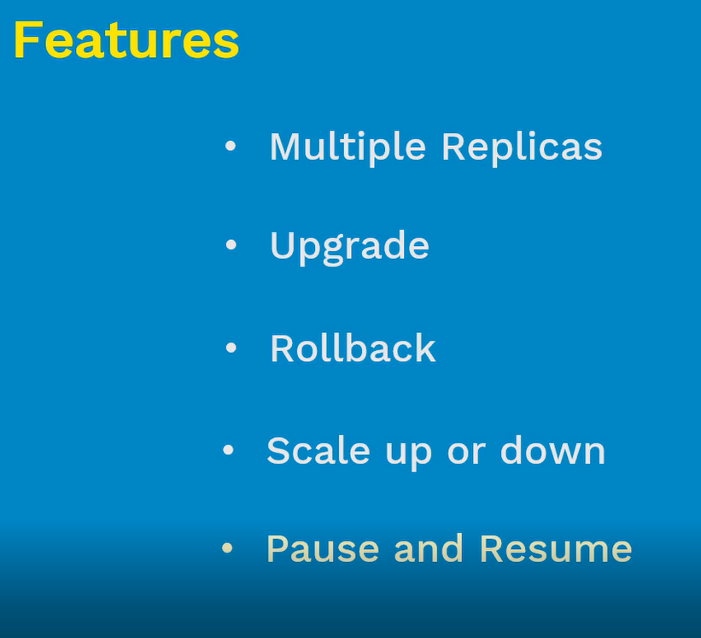

## Deployment Types:

* **Recreate**

1. It is a dummy deployment which consists of shutting down version A and after making sure version A is turned off then you start deployment version B
2. During this switching from version A to version B, there will be a downtime of service.
3. This is very easy to setup

* **RollingUpdate (Ramped or Incremental)**

1. This deployment will slowly roll out version of an app by replacing instances one after the other until all the instances are successfully rolled out
2. Example: Let’s assume there are 10 instances behind the LB then update strategy starts with one instance of version B is deployed, when version B is ready to accept the traffic then instances is added to the pool then one instance of version A is removed from pool and shutdown
3. RollingUpdate is the default strategy of upgrade in Kubernetes
4. It is easy to use but this upgrade will take sometime

* **Canary**

1. It consists of gradually shifting production traffic from version A to version B
2. Let’s imagine that there are 10 instances of app version A running inside your cluster
3. We use this Canary deployment, when we don’t want to upgrade all at once
4. Let’s assume that, we first upgrade two instances from version A to version B, then do some testing. If test results are good, then we upgrade remaining 8 instances from version A to version B
5. Once version B is ready, the we completely deleted the version A. Basically this is ideal deployment method for someone who want to test before it is deployed 100%

* **Blue / Green**

1. Using this deployed method, version B(green) is deployed alongside with version A(Blue) with exact same amount of instances
2. After testing newer version, the traffic is switch from version A to version B at the LB level
3. Advantage of this deployment is Instance Rollout or Rollback

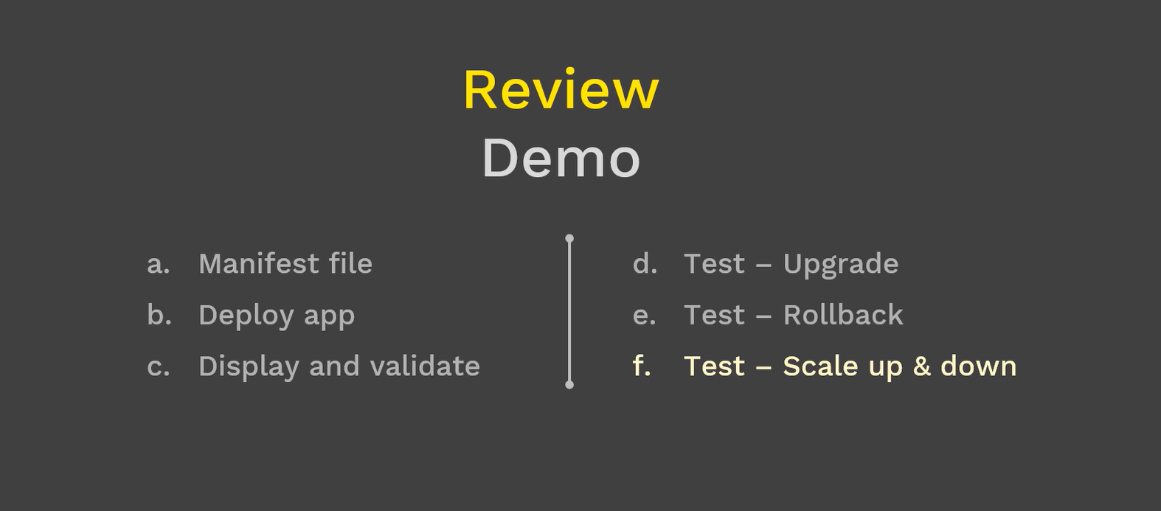

### Manifest file:

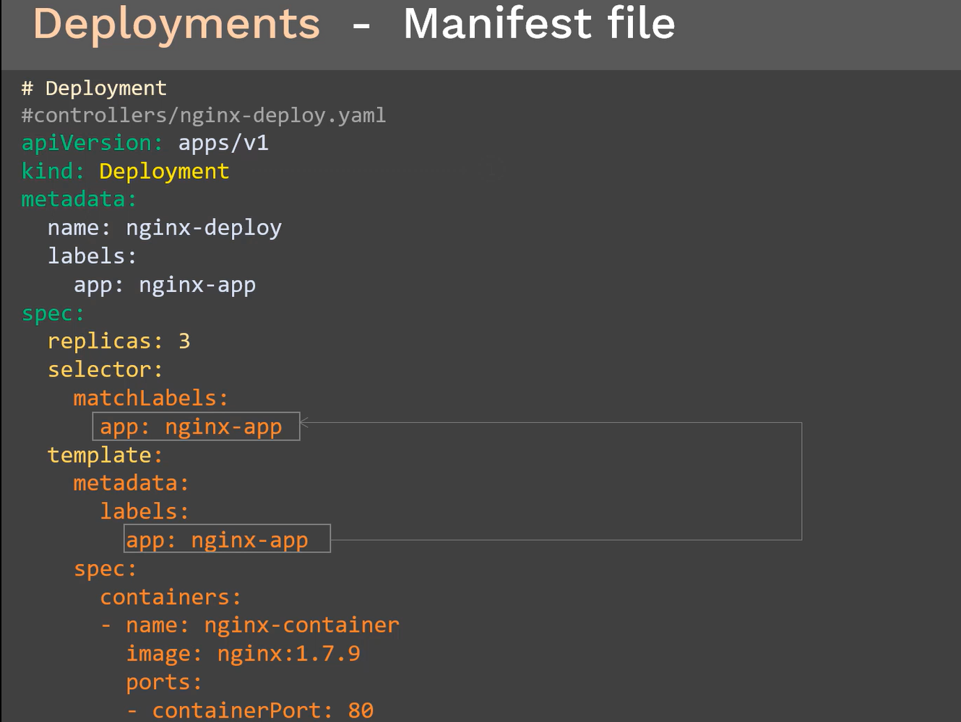

### Deployments – Create & Display:

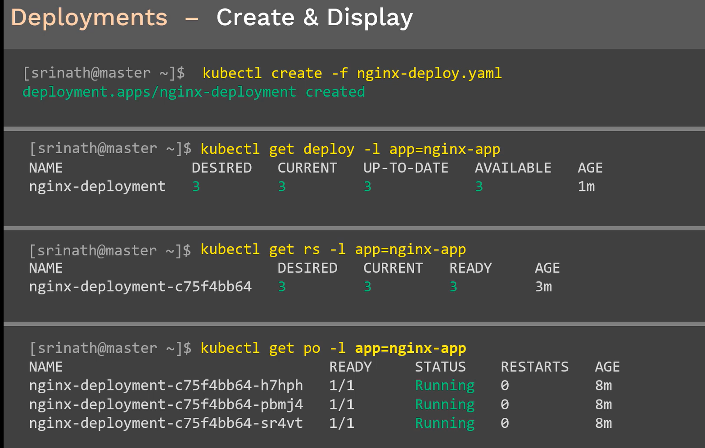

### Deployments – Describe:

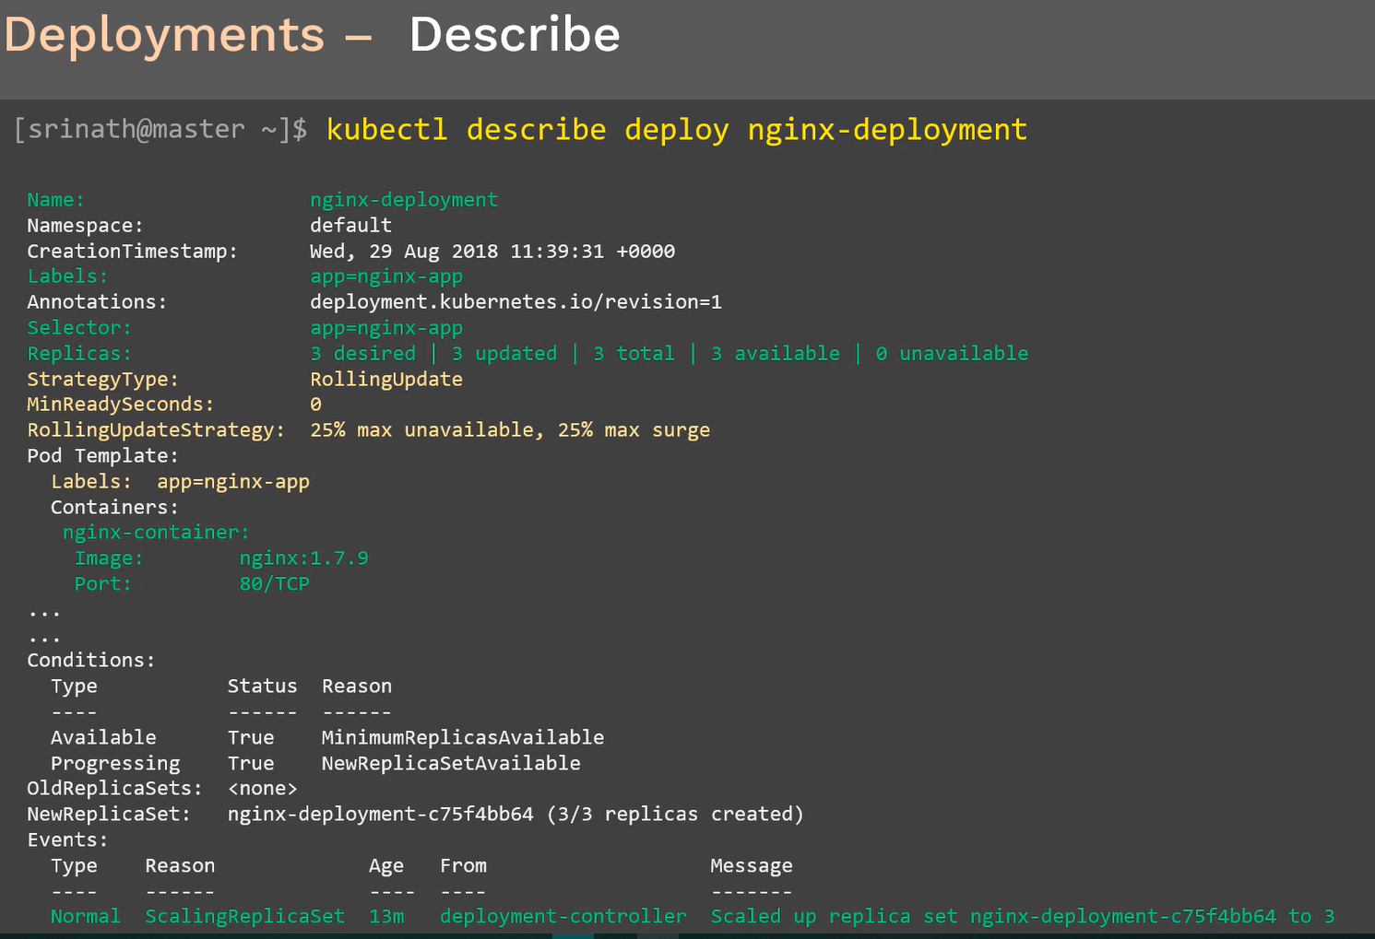

### Updating nginx from 1.7 to 1.9

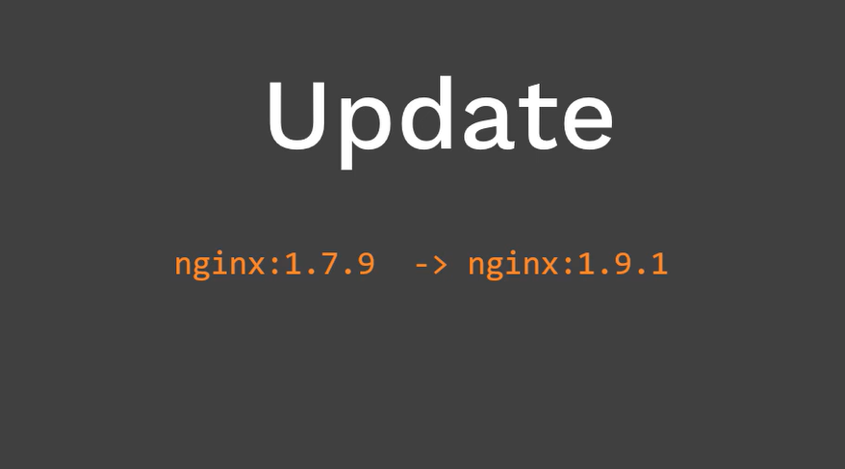

For upgrade, there are two ways to do it

1. kubectl set command

2. kubectl edit command

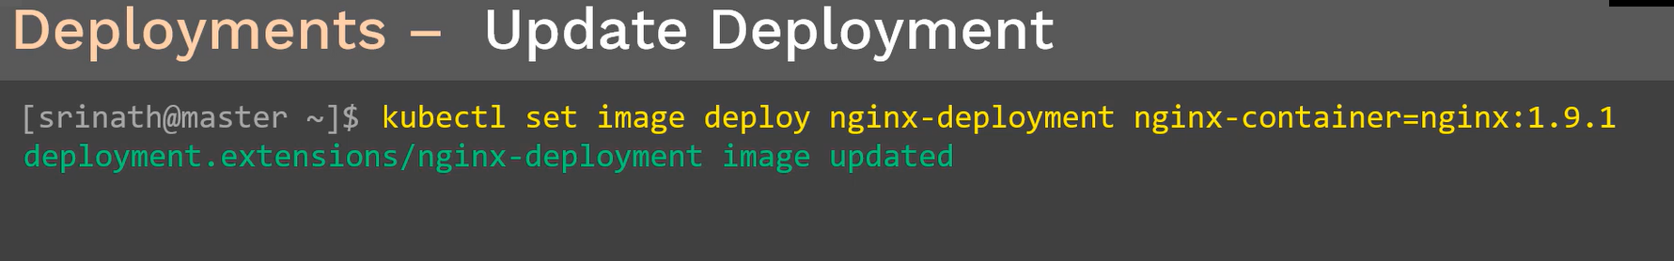

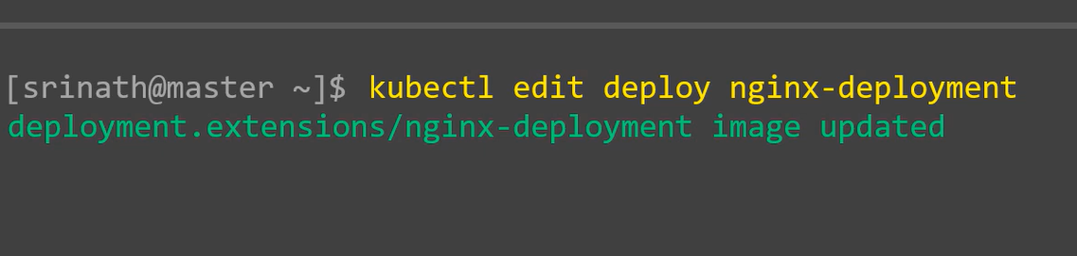

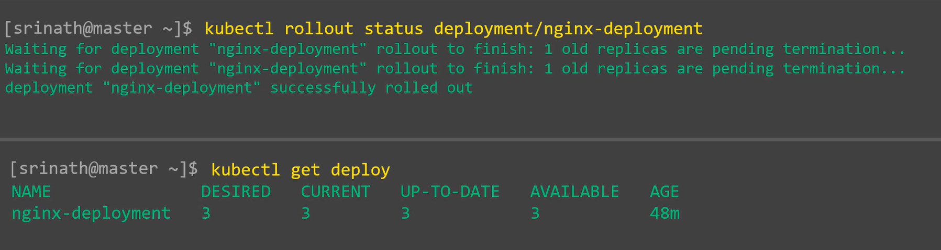

### Rollback:



Accidentally we provide from 1.9.9 to 1.91 in the deployment

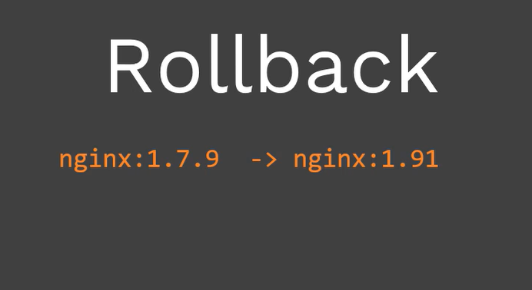

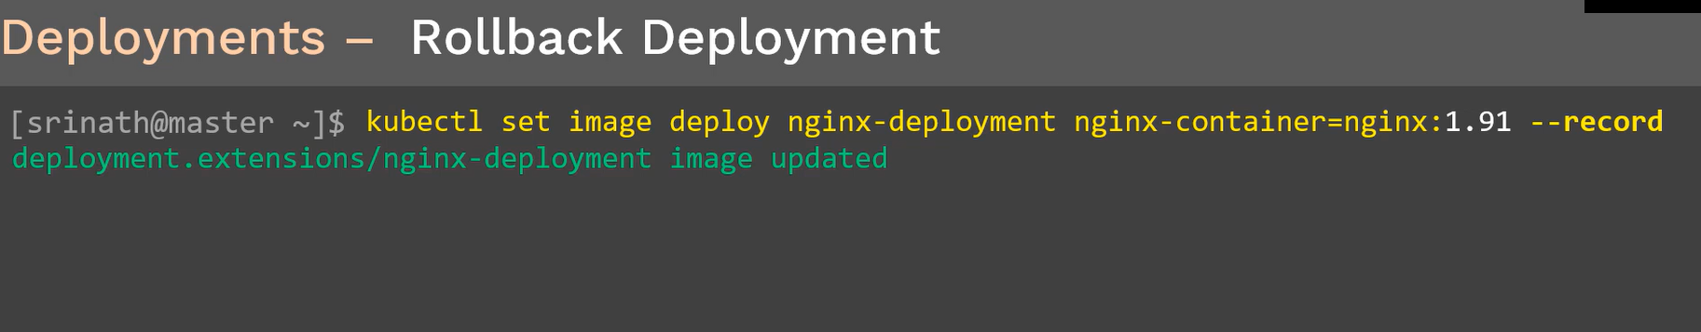

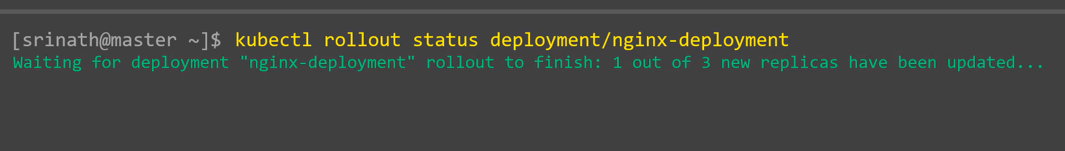

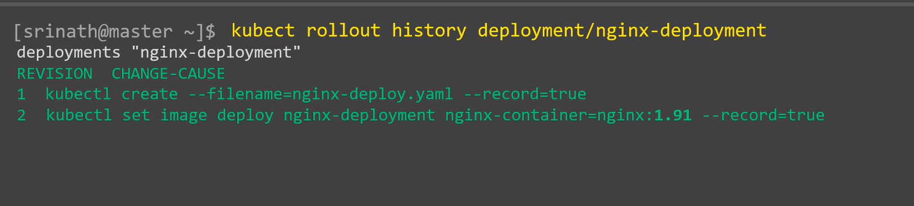

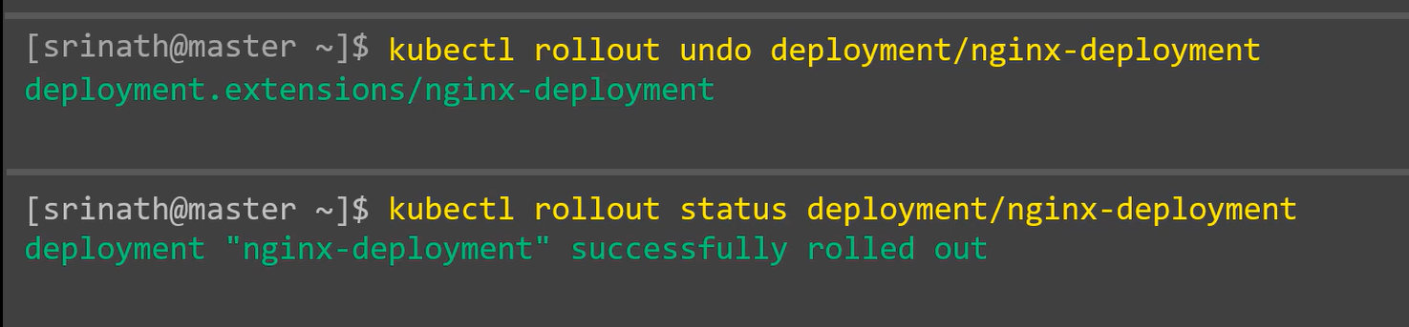

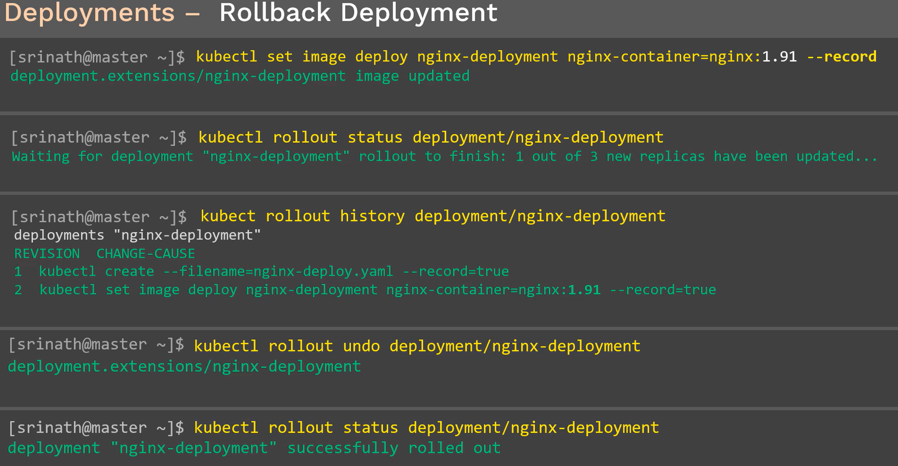

### Scale Up & Down

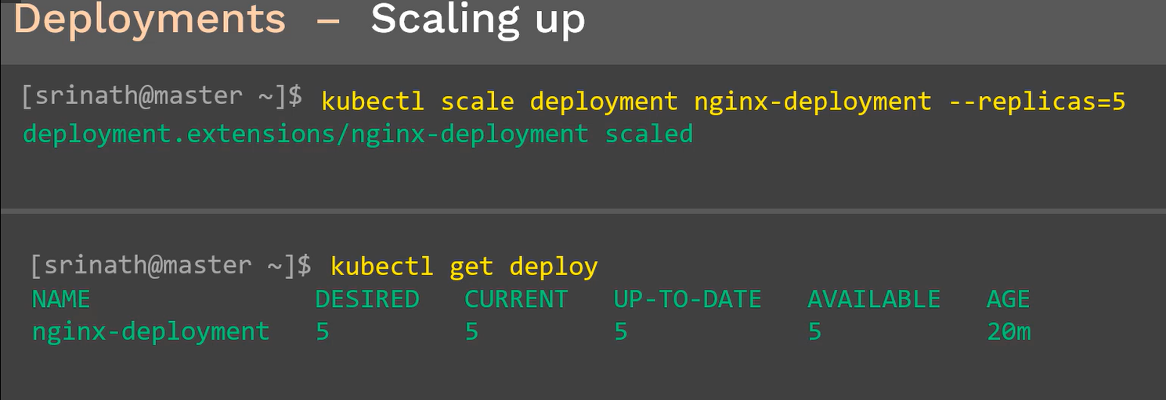

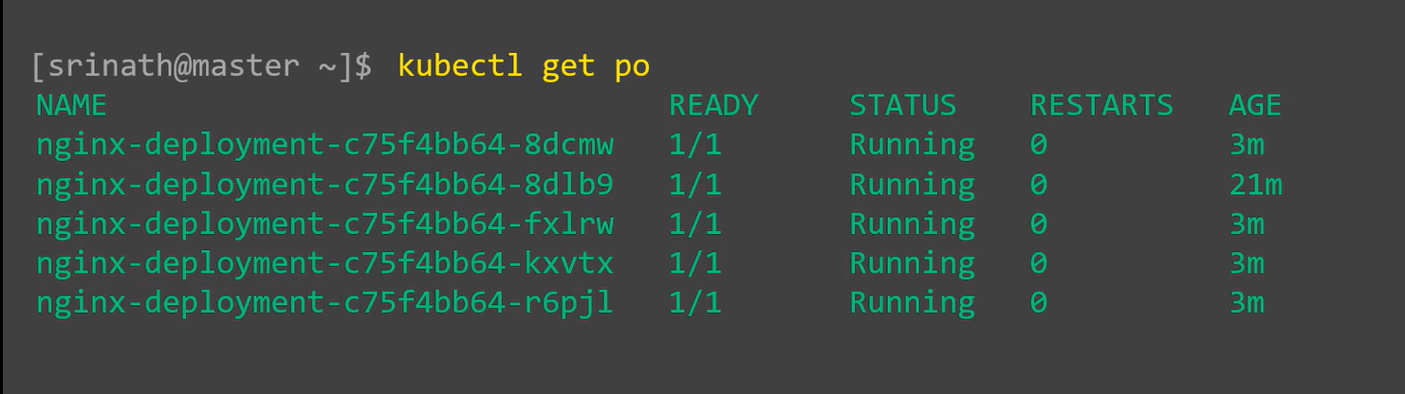

### Scale Down:

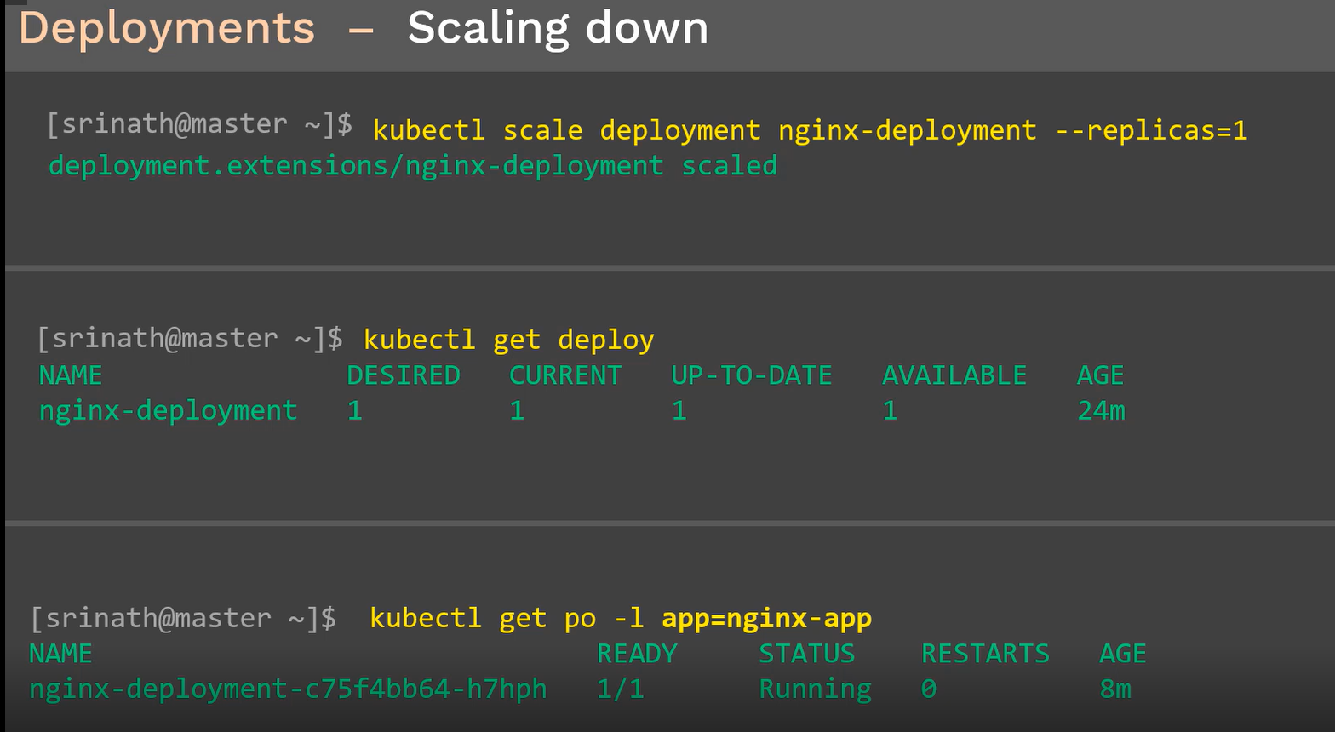

### Delete:

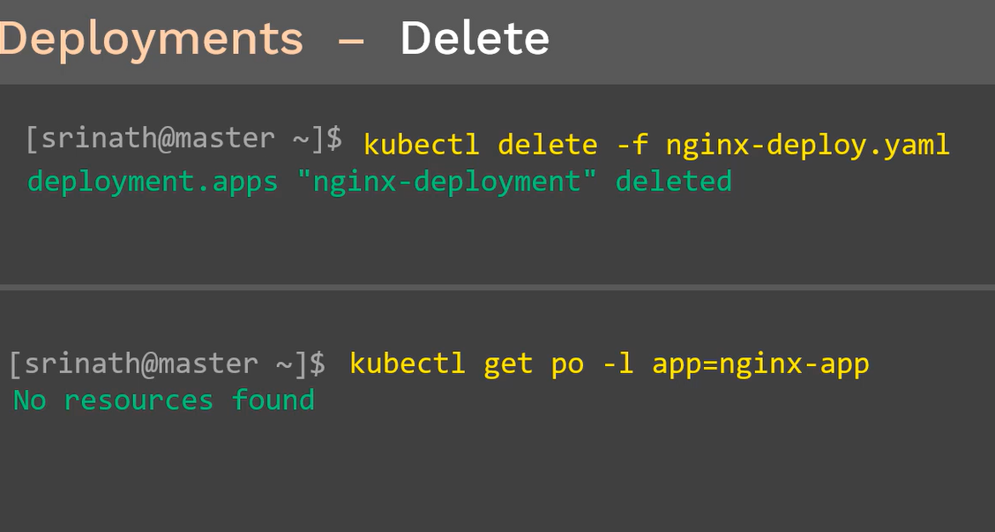

### Summary:

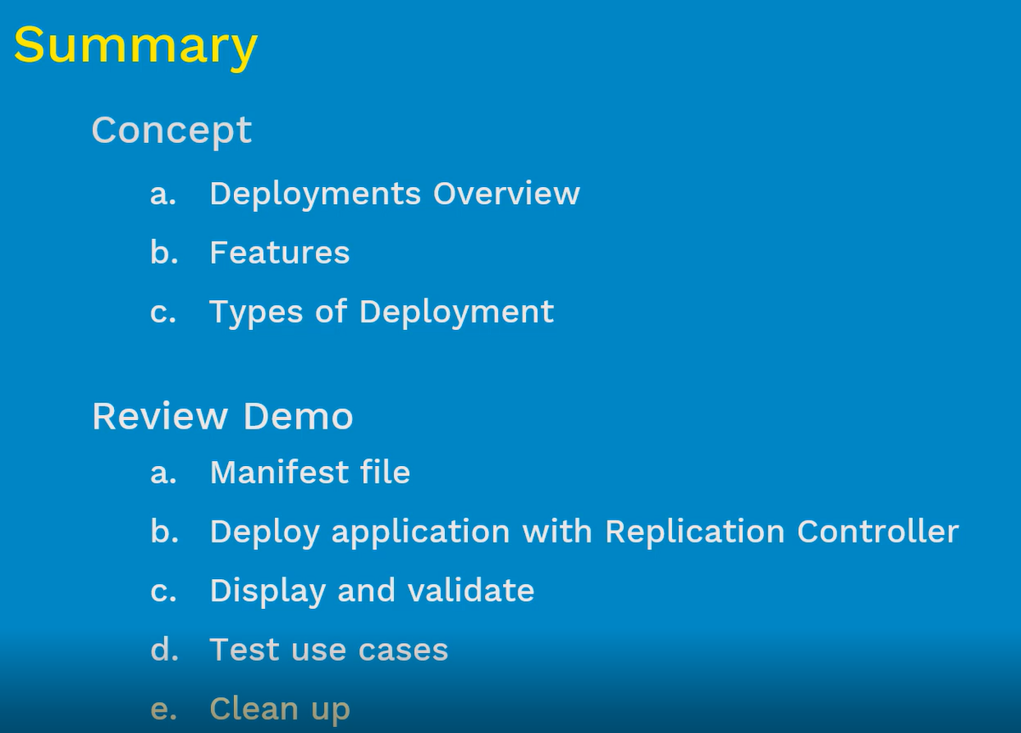

Demo:

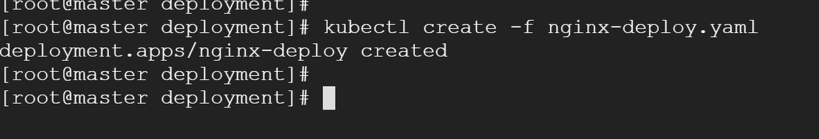

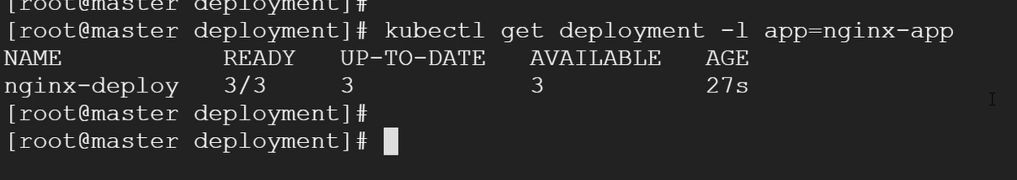

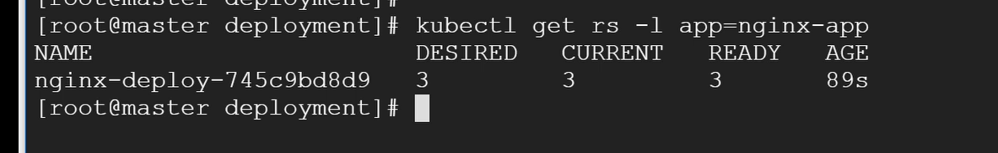

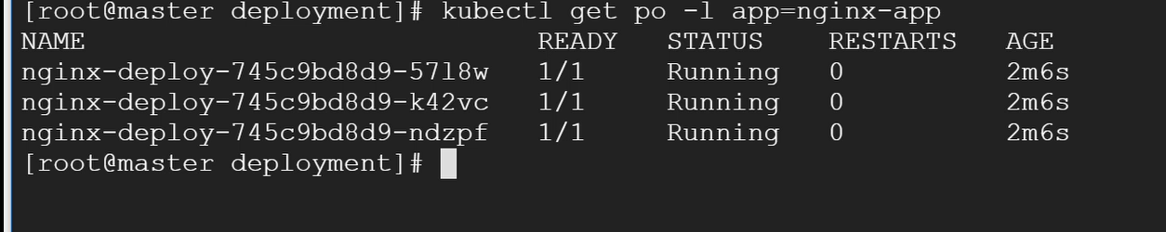

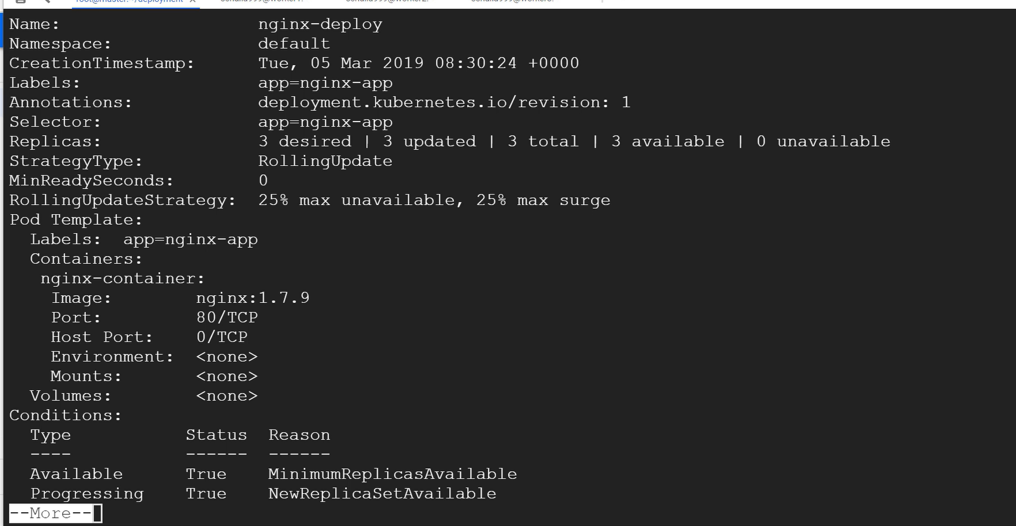

## Rollback update



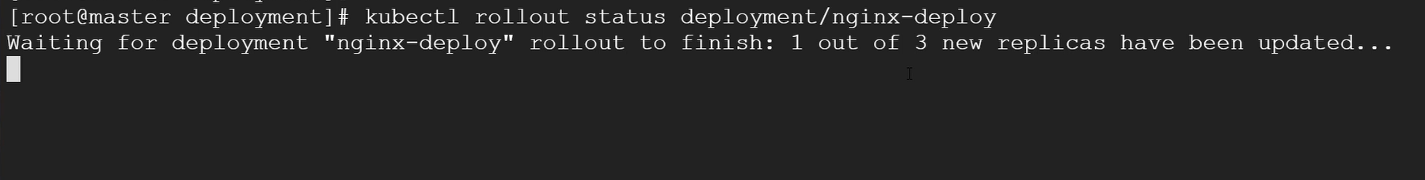

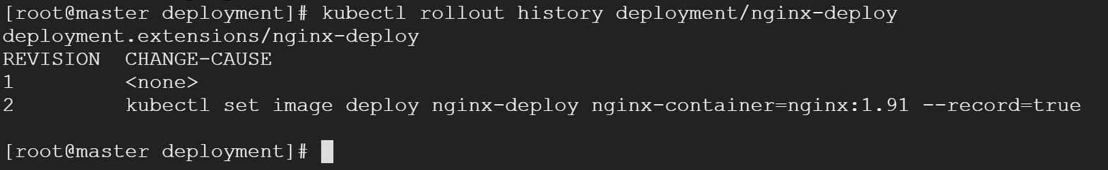

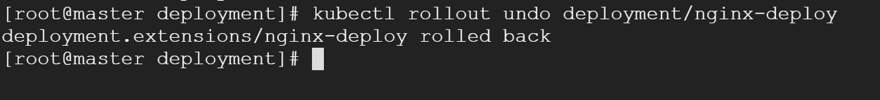



## Updating Version





This command will open the manifest file of currently running nginx-deployment. If you go down that file there will be deployment manifest file, there is an option of image version on the file

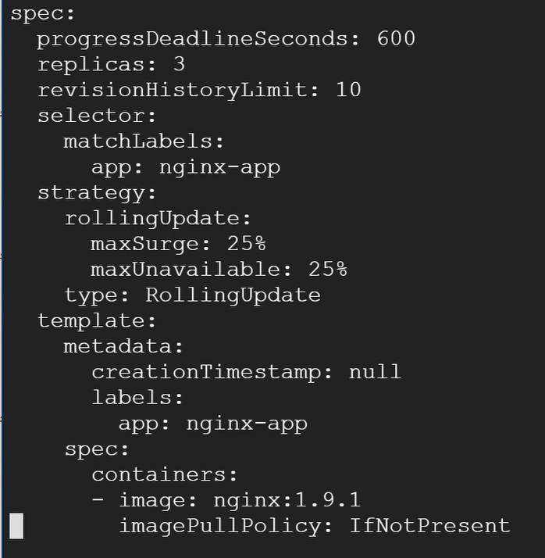

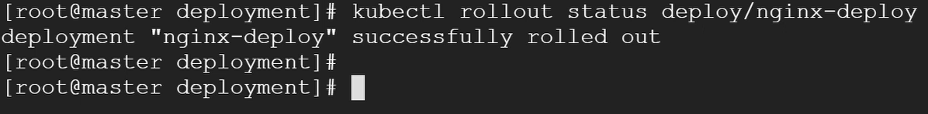

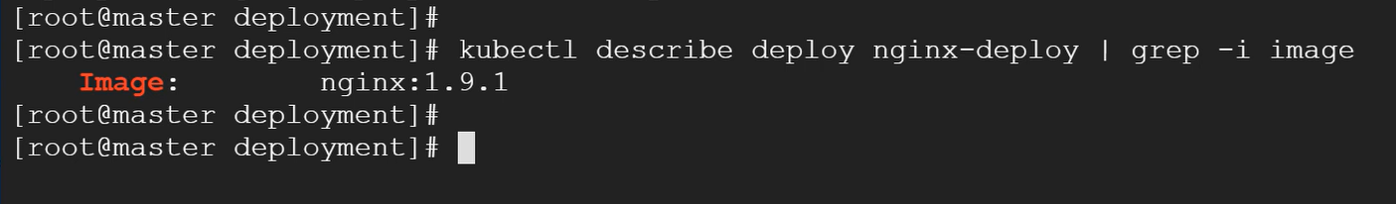

Deployments are used primarily for deploying new versions using various deployments strategies. Besides that it is also used for scaling up/down using deployment depending upon the traffic

## Scaling UP:

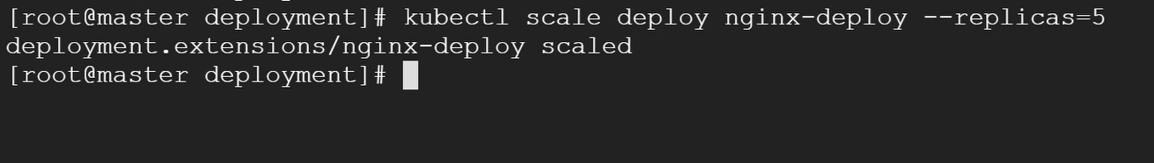

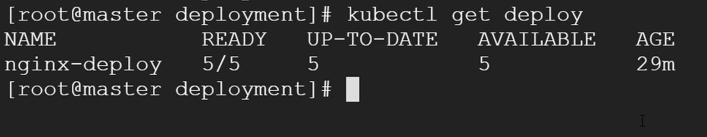

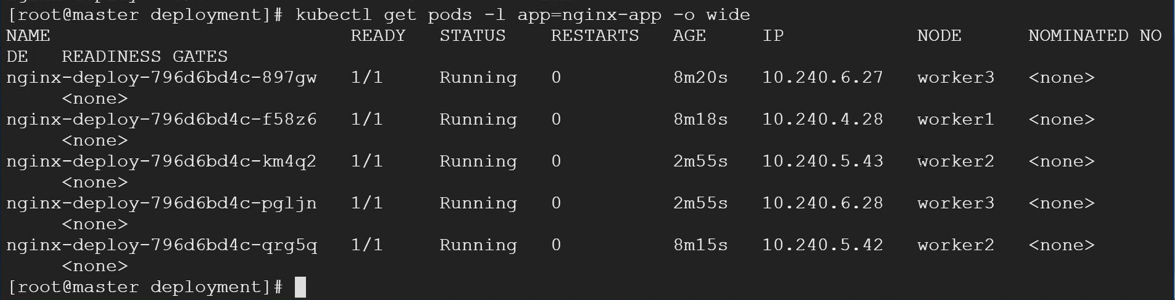

## Scaling down:

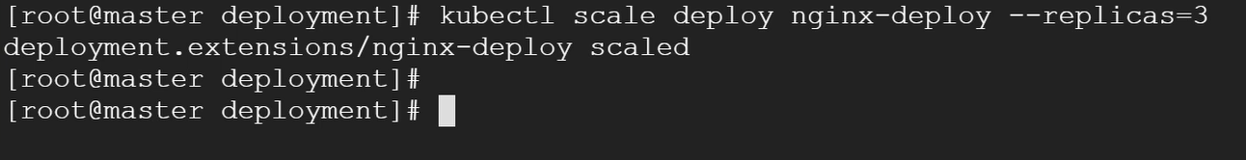

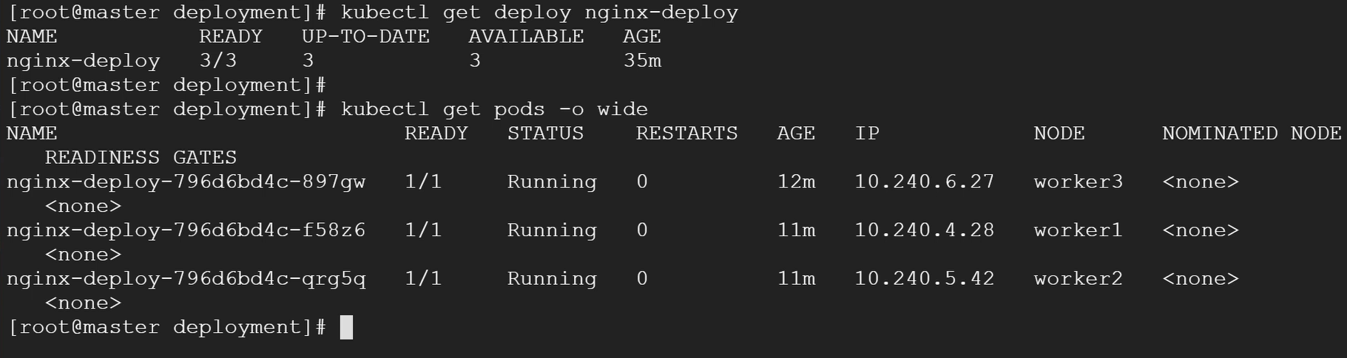

## Cleanup:

